NAIROBI CITY CENTRE HOSPITAL

WEBSITE

**NAIROBI CITY CENTER WEBSITE PROJECT**

**INTRODUCTION**

In this particular web project, it is developed for basically allowing patients to register themselves and their next of kin and allow patients to view their records and their next of kin records and also to provide patients with means for communication with the hospital and also give extended information on the hospital. The web project requirements were divided into different numbers and therefore the documentation is for you to understand how I approached every question give you my analysis of each question and also to show you the output after every question.

**QUESTION** **1**

In the first question I was required to build a homepage through which the user would view patient and next of kin details, register the next of kin details and patient details and also view the hospital information.

To create the homepage, I used the html file index to create different containers which include:

* Container: Contains all the contents of the website
* Header: Contains the title and the logo of the website.
* Menu: Contains the list of options one can choose from.(it also contains sub menus).
* Sidebar: Contains the list of options one can choose from.(it also contains sub menus).
* Main body: It contains the content of each menu chosen.
* Footer: It contains the copyright of the hospital, my name and index number.

I also used THE html file index to write down the contents of each container. I also used the CSS files style to edit and give color to each container and to each text within the container.

The output of the homepage is as shown below:

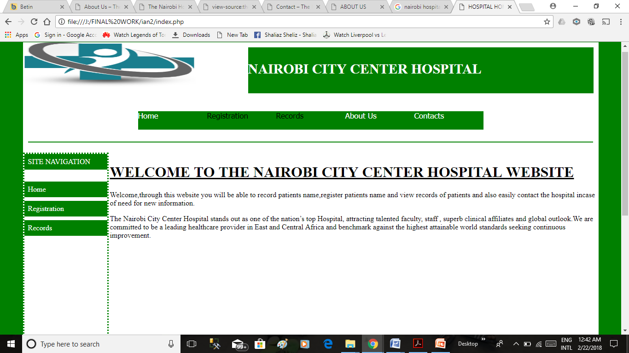

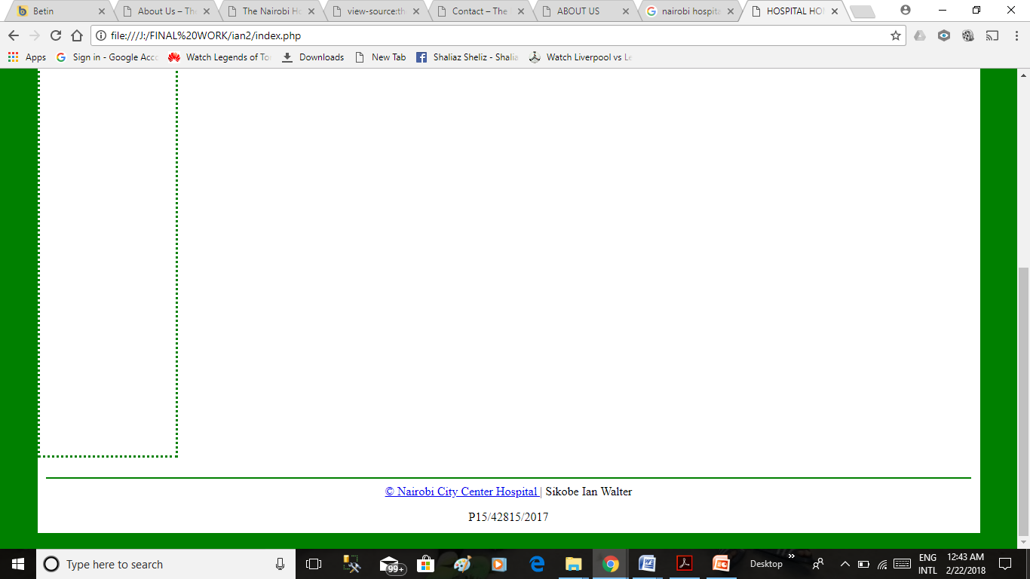

FIG 1.1: WEBSITE HOMEPAGE

**QUESTION 2**

In the second question I was required to create forms for registering patients and next of kin. The first form is accessed after pressing the Patient Registration menu. To create this I first used HTML files and CSS files used in the first question to duplicate the user interface and in the main Body of the user interface I created the first form which was for registering patients. To create the form I used containers which include;

* Divform;Contains all the contents of the form.
* DivformH; Contains the header of the form.
* Uform; Contains the input fields of the patients’ details together with their appropriate labels.

The data fields that required drop-down boxes were given their respective dropdown boxes. After data input fields there is presence of Send button which on pressing saves the data input of the user into the database and also on pressing it if data input is incomplete or has an error the field containing input be surrounded by red outline and an error message will appear beside the input field. There is also the presence of the clear button which on pressing deletes the data input. The above actions and validations are performed by the functions.js JavaScript file. The output of the form is as shown below:

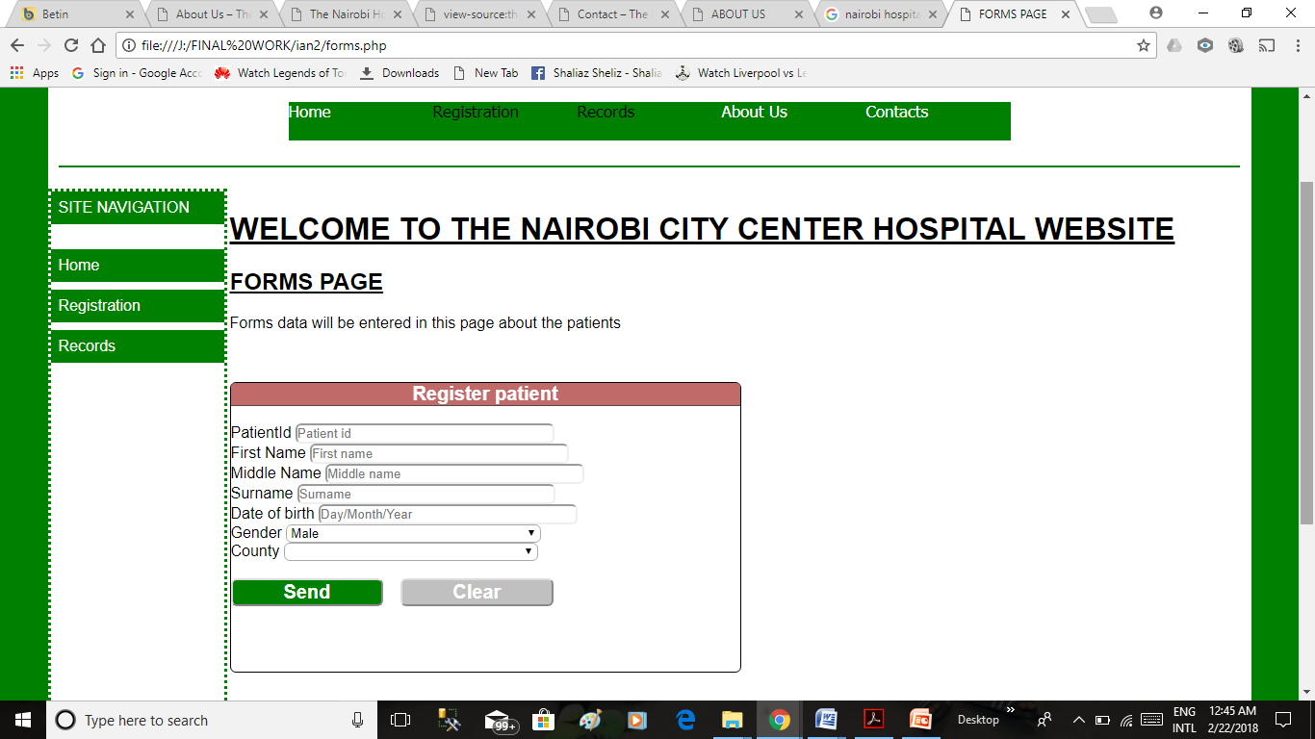

FIG1.2: PATIENTS FORM

The first form is accessed after pressing the next of kin Registration menu. To create the next form which was for registering next of kin data I also duplicated the same user interface and created the form within the main body of the user interface.To create the form I used containers;

* Divform; Contains all the contents of the form.
* DivformH; Contains the header of the form.
* Uform; Contains the input fields of the patients’ details together with their appropriate labels.

In the first data field I it created such that it would fetch the patient’s id from the database and the user would have to choose. After data input fields there is presence of Send button which on pressing saves the data input of the user into the database and also on pressing it if data input is incomplete or has an error the field containing input be surrounded by red outline and an error message will appear beside the input field. There is also the presence of the clear button which on pressing deletes the data input. The above actions and validations are performed by the functions.js JavaScript file. The output of the form is as shown below:

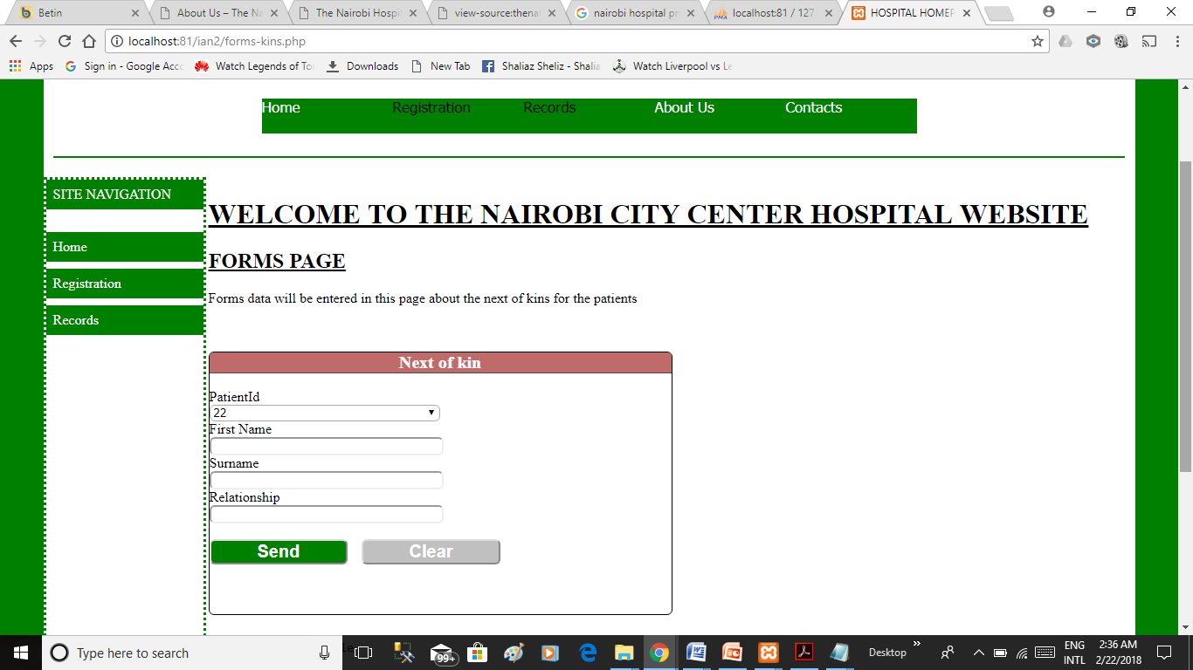

1.3: NEXT OF KIN FORM

**QUESTION 3**

In the third question I was required to write a PHP script that connects to a database and inserts data from the Patients Registration form into a table patient which would contain patients’ information. To do this first I created a database called ‘nairobicitycenter’ and created a table called ‘patient’ and filled it with the appropriate fields. Then I connected the database to the Patient Registration form by use of the file ‘talent.php’ that enabled data entered In the form is to be stored in the table ‘patient’.The table created is as shown below;

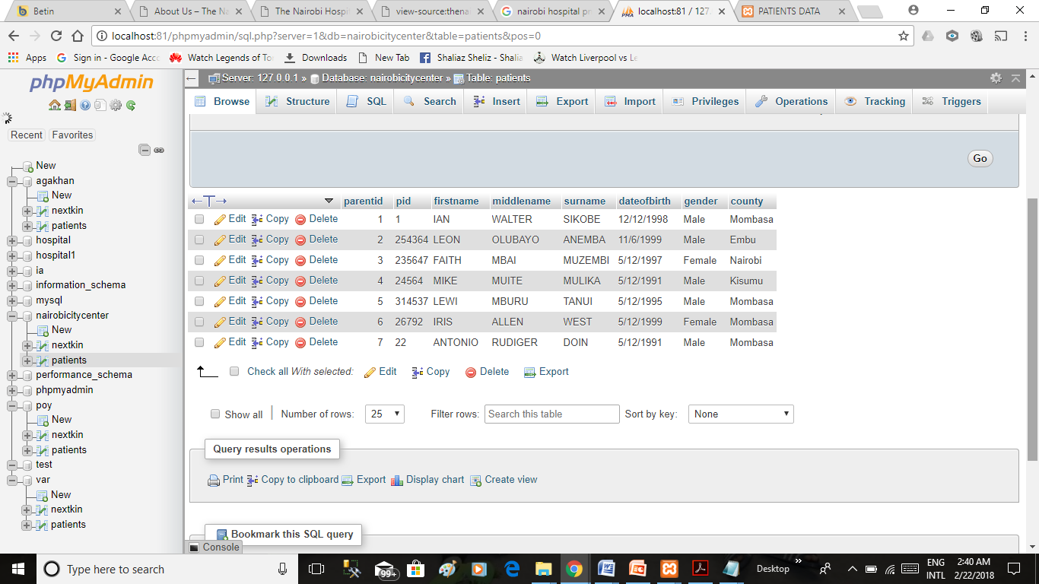FIG 1.4: TABLE FOR PATIENTS IN DATABASE

**QUESTION 4**

In the fourth question I was required to write a PHP script that connects to a database and inserts data from the Next-of-kin Registration form into a table nextkin which would contain patients’ next of kin information. To do this first I created a table called ‘nextkin’ in the database called ‘nairobicitycenter’ and filled it with the appropriate fields. Then I connected the database to the Patient Registration form by use of the file ‘kin.php’ that enabled data entered In the form is to be stored in the table ‘nextkin’. The table created is as shown below;

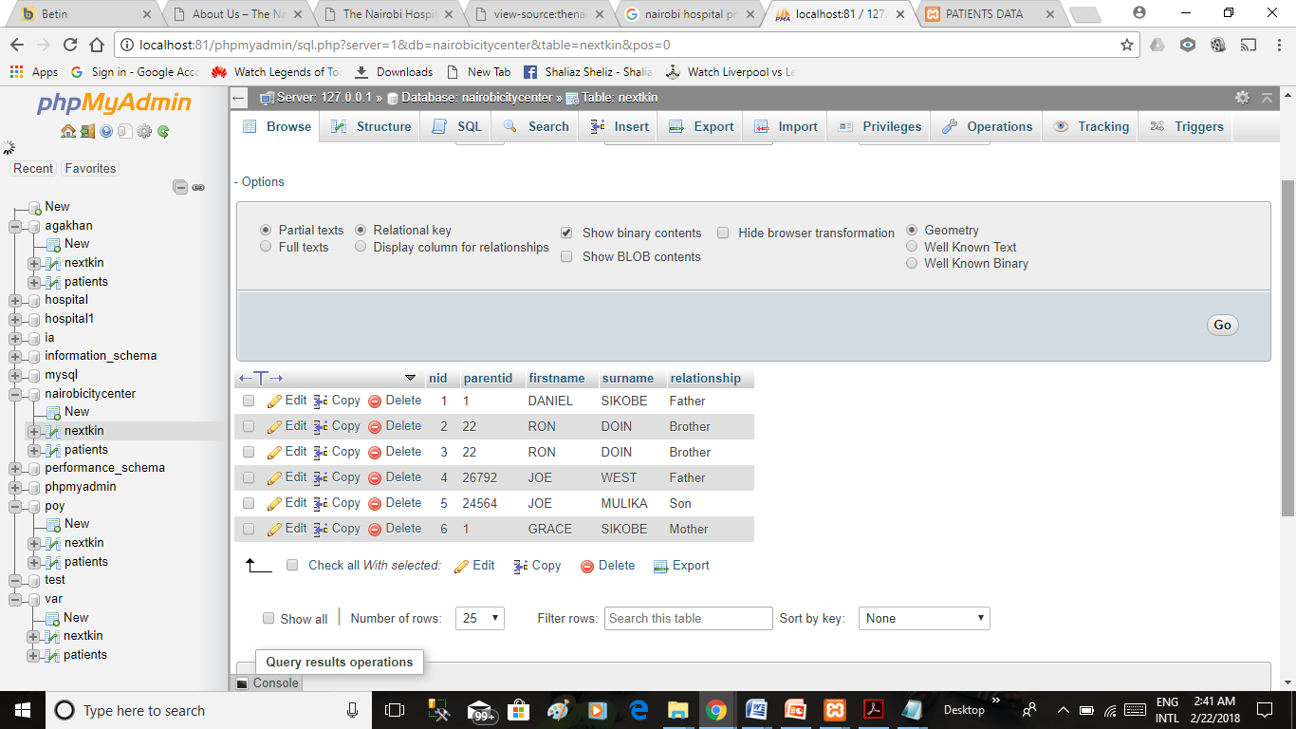

FIG 1.5: TABLE FOR NEXT KIN IN DATABASE

**QUESTION 5**

In the fifth question I was required to create a table similar to the table ‘patient’ together with its records in the database and a table similar to the table ’nextkin’ but based on the inner-join query that draws data from the tables ’parent ’and ‘nextkin’. The first table in the website is accessed after pressing the Patient Records menu. To create this I first used HTML files and CSS files used in the first question to duplicate the user interface and in the main Body of the user interface I created the first table which contained patients details.Then I used PHP scripts to enable the created table to fetch records of data from the table in the database and I also enabled the table to be in the form of zebra-stripes as instructed by the use of the js.js JavaScript file .I also used PHP scripts to calculate the age of each patient . The table created is as shown below;

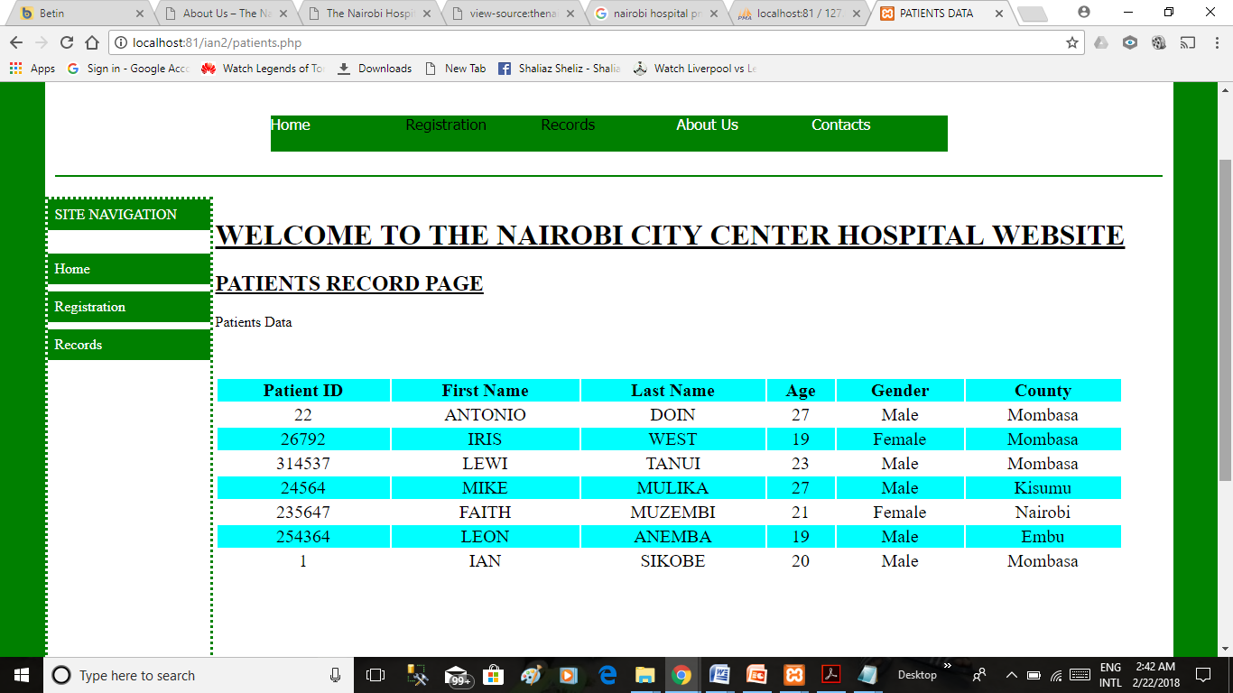

FIG 1.6: PATIENTS RECORD TABLE IN WEBSITE

The second table in the website is accessed after pressing the next-kin Records menu.. To create the second table I first used HTML files and CSS files used in the first question to duplicate the user interface and in the main Body of the user interface I created the secondtable on the basis of the inner join query which contained the next of kin details.Then I used PHP scripts to enable the created table to fetch records of data from the table in the database and I also enabled the table to be in the form of zebra-stripes as instructed by the use of the js.js JavaScript file. The table created is as shown below;

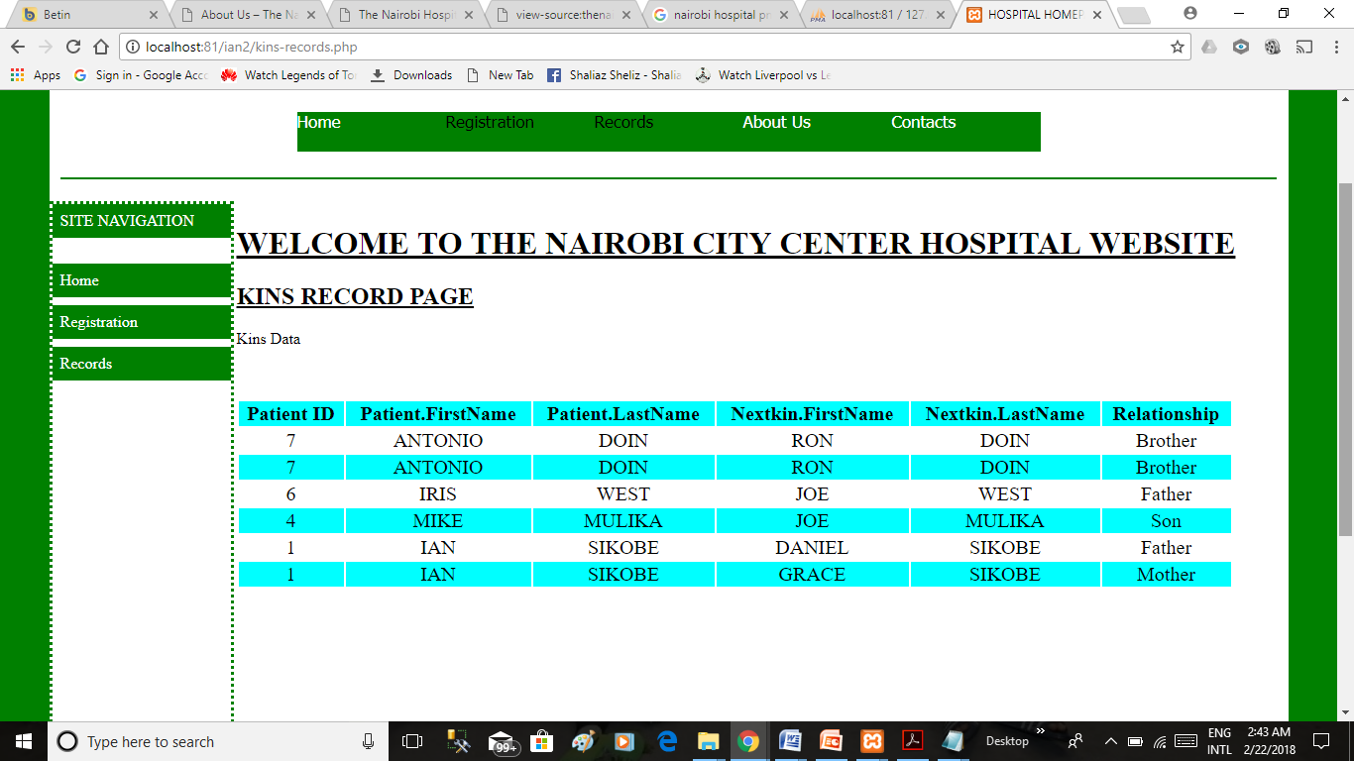FIG 1.7: NEXT OF KIN RECORD TABLE IN WEBSITE

**OPTIONAL PAGES**

I created optional pages About Us and Contact. These pages can be accessed by pressing the About Us and Contact option on the Menu Respectively. Their main framework is still based on the main user interface and their respective contents are in the main Body. The About Us page mainly talks about the hospital and its output is as below;

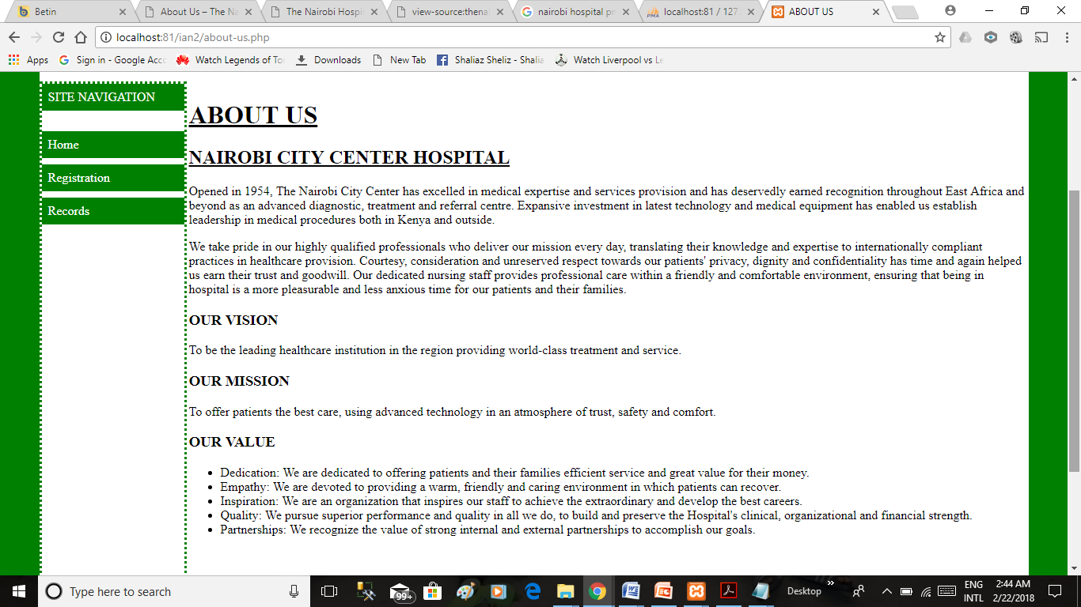

FIG 1.8: ABOUT US PAGE

The Contact page mainly talks about the hospital and its output is as below;

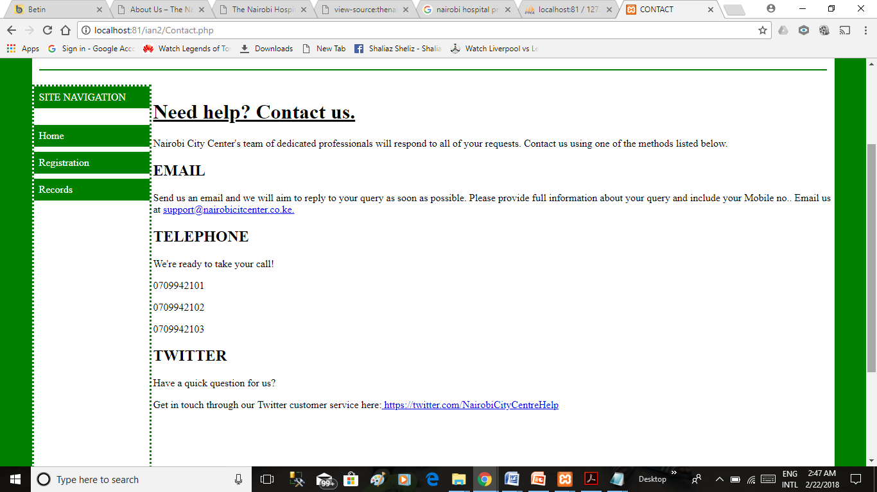

FIG 1.9: CONTACT PAGE

**IMPORTANT STEPS TO NOTE:**

To use this web project:

1. Open localhost, create a database for your preferred hospital eg nairobicitycentre
2. Import details to populate in with table names and details within the tables
3. Open the website using the local host of xamp and the name of the folder holding the website files, navigate the website and do whatever option you want on the menu.